**EXPERIMENT-1**

**INSTALLATION OF GIMP AND BLENDER**

**Installation of GIMP:**

**Step – 1**

First and foremost step to download blnder is to **Downaload the GIMP installer**. One can download the GIMP installer free of cost from its website <https://www.gimp.org/downloads/>.

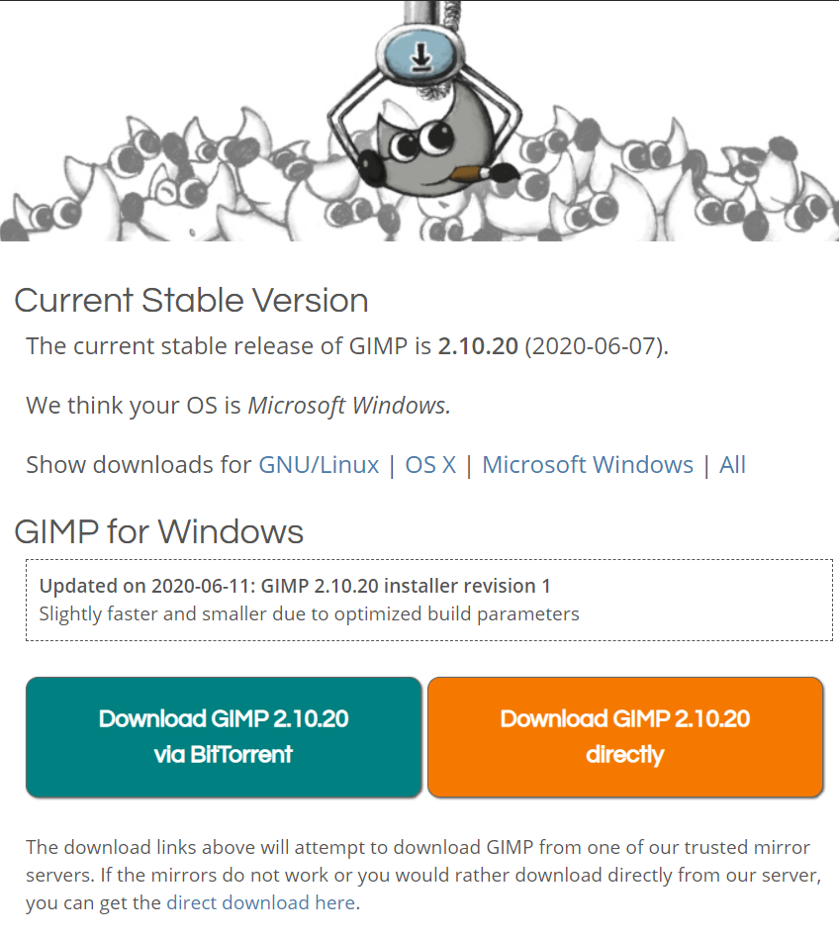

**Step – 2**

Go to the downloads section and **run the GIMP installer**.

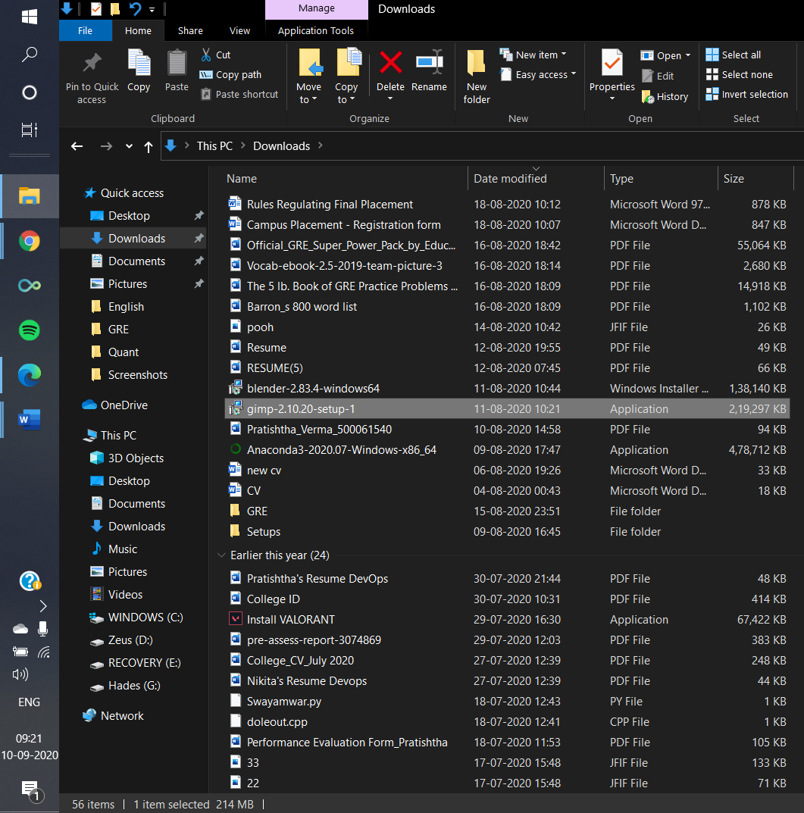

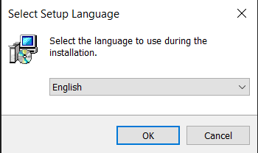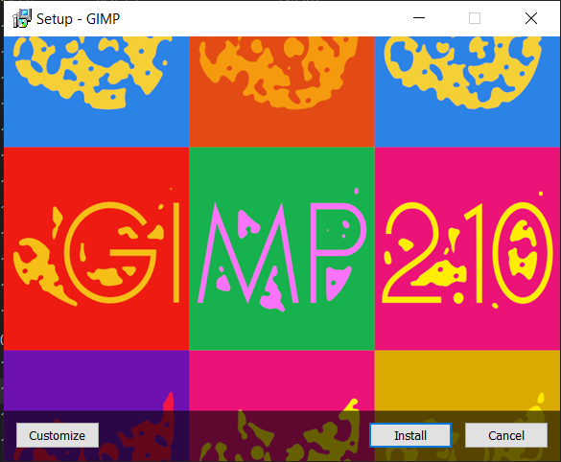

**Step – 3**

**Follow the instructions** to install and setup GIMP.

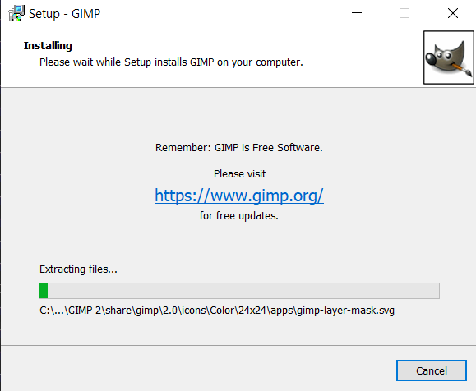

**Step – 4**

**Finish the installation,** which may take few minutes to complete.

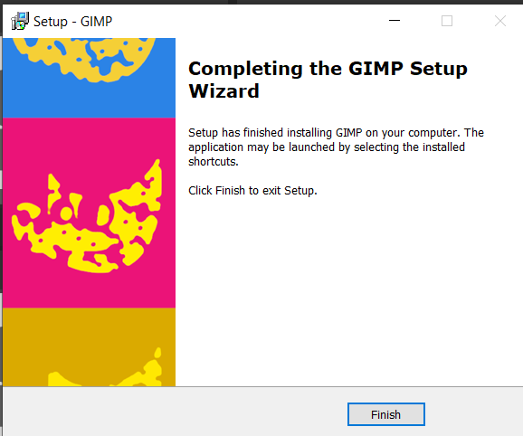

**Step – 5**

**Open GIMP. Start using GIMP** once its been properly installed.

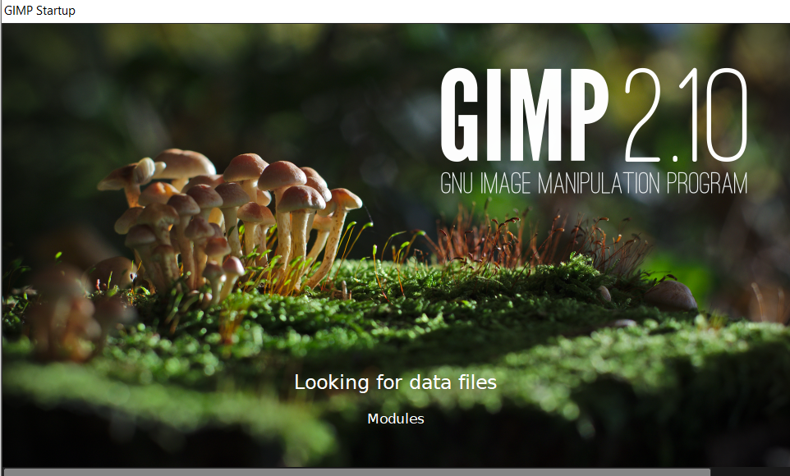

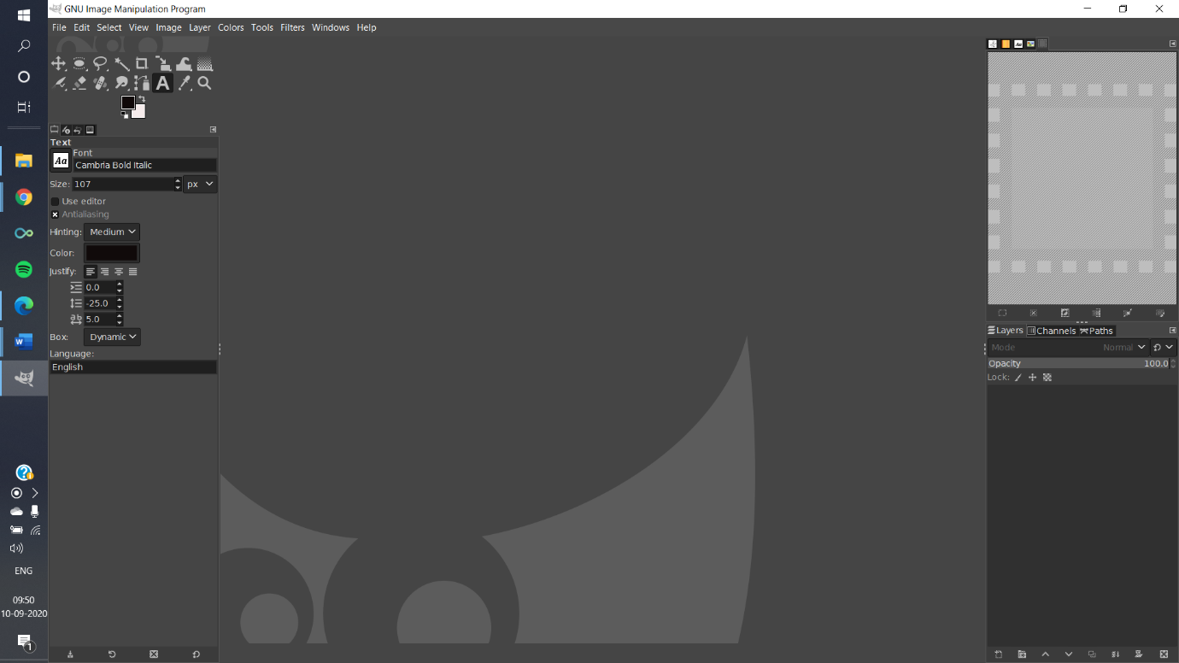

**Installation of Blender:**

**Step – 1**

First and foremost step to download blnder is to **Downaload the Blender installer**. One can download the GIMP installer free of cost from its website <https://www.blender.org/download/> .

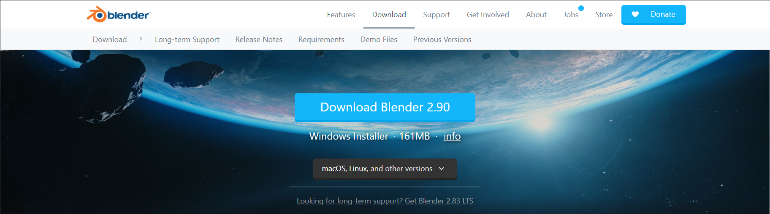

**Step – 2**

Go to the downloads section and **run the Blender installer**.

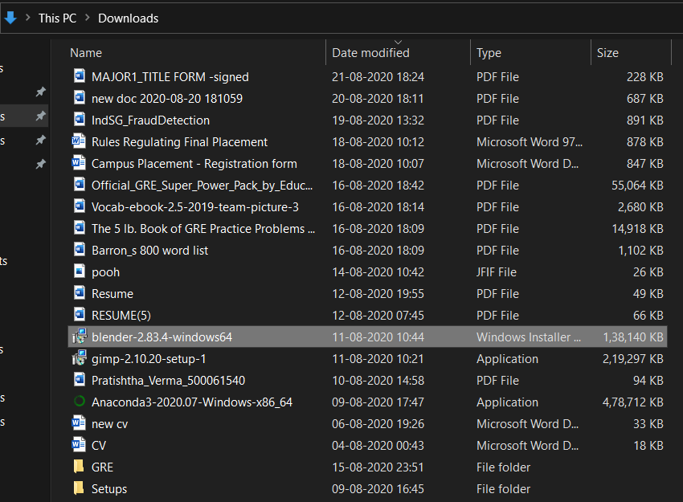

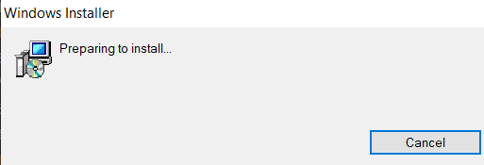

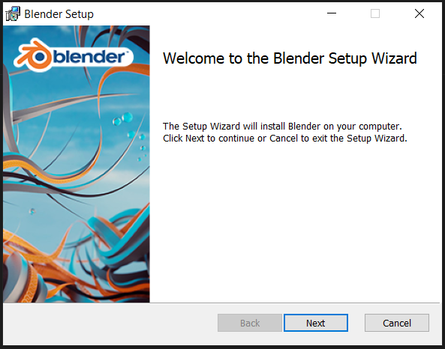

**Step – 3**

**Follow the instructions** to install and setup Blender. **Agree to the terms and conditions** when prompted, click **I AGREE** and move to next phase.

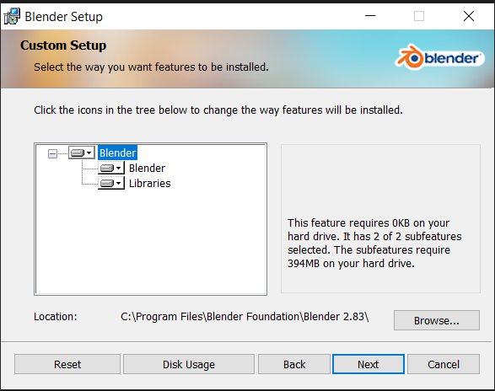

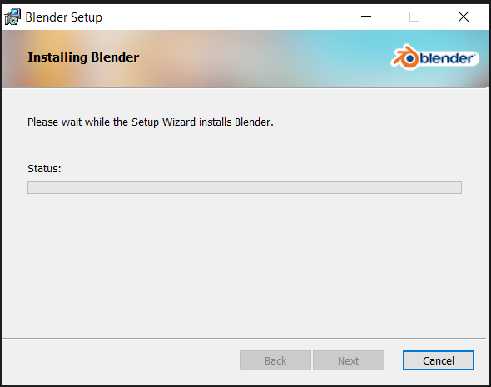

**Step – 4**

**Finish the installation,** which may take few minutes to complete. It will probably take less than 5 minutes. Click on finish after its completed. Blender is now installed on your computer.

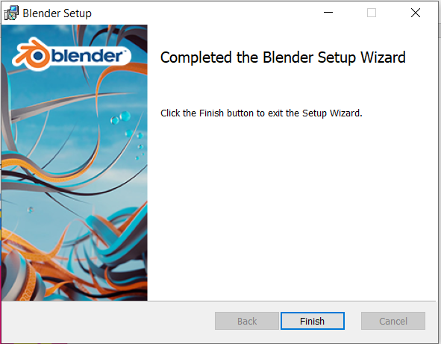

**Step – 5**

**Open Blender. Start using Blender** once its been properly installed. You can now start exploring the application.

